Exp No: 17
UART INTERFACING USING INTERRUPT IN KEIL
Code:
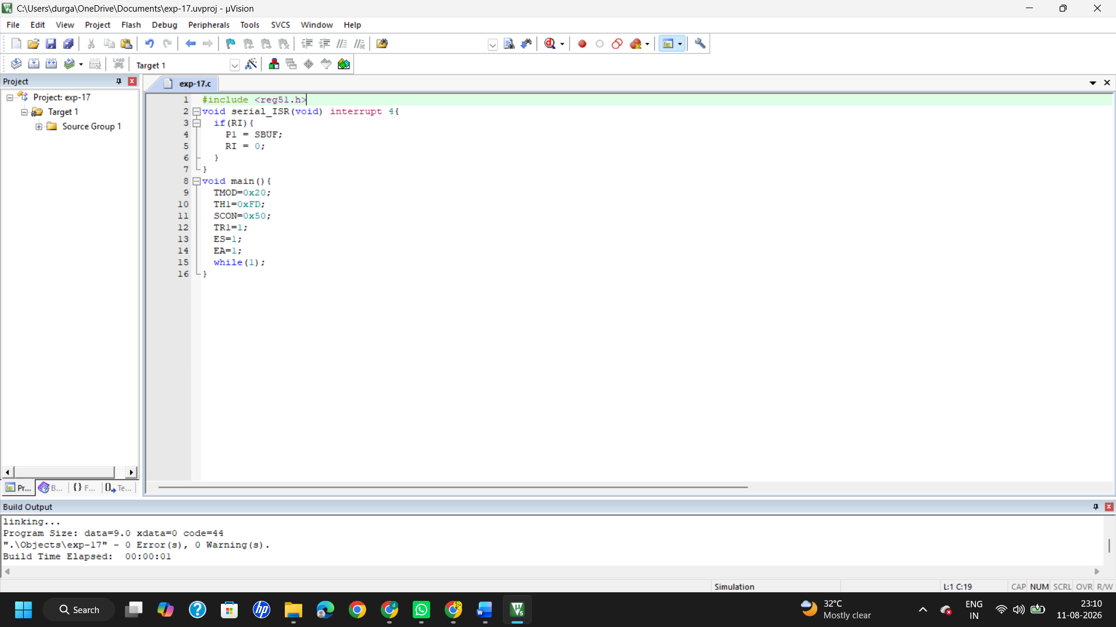
Output:
Before interrupt:
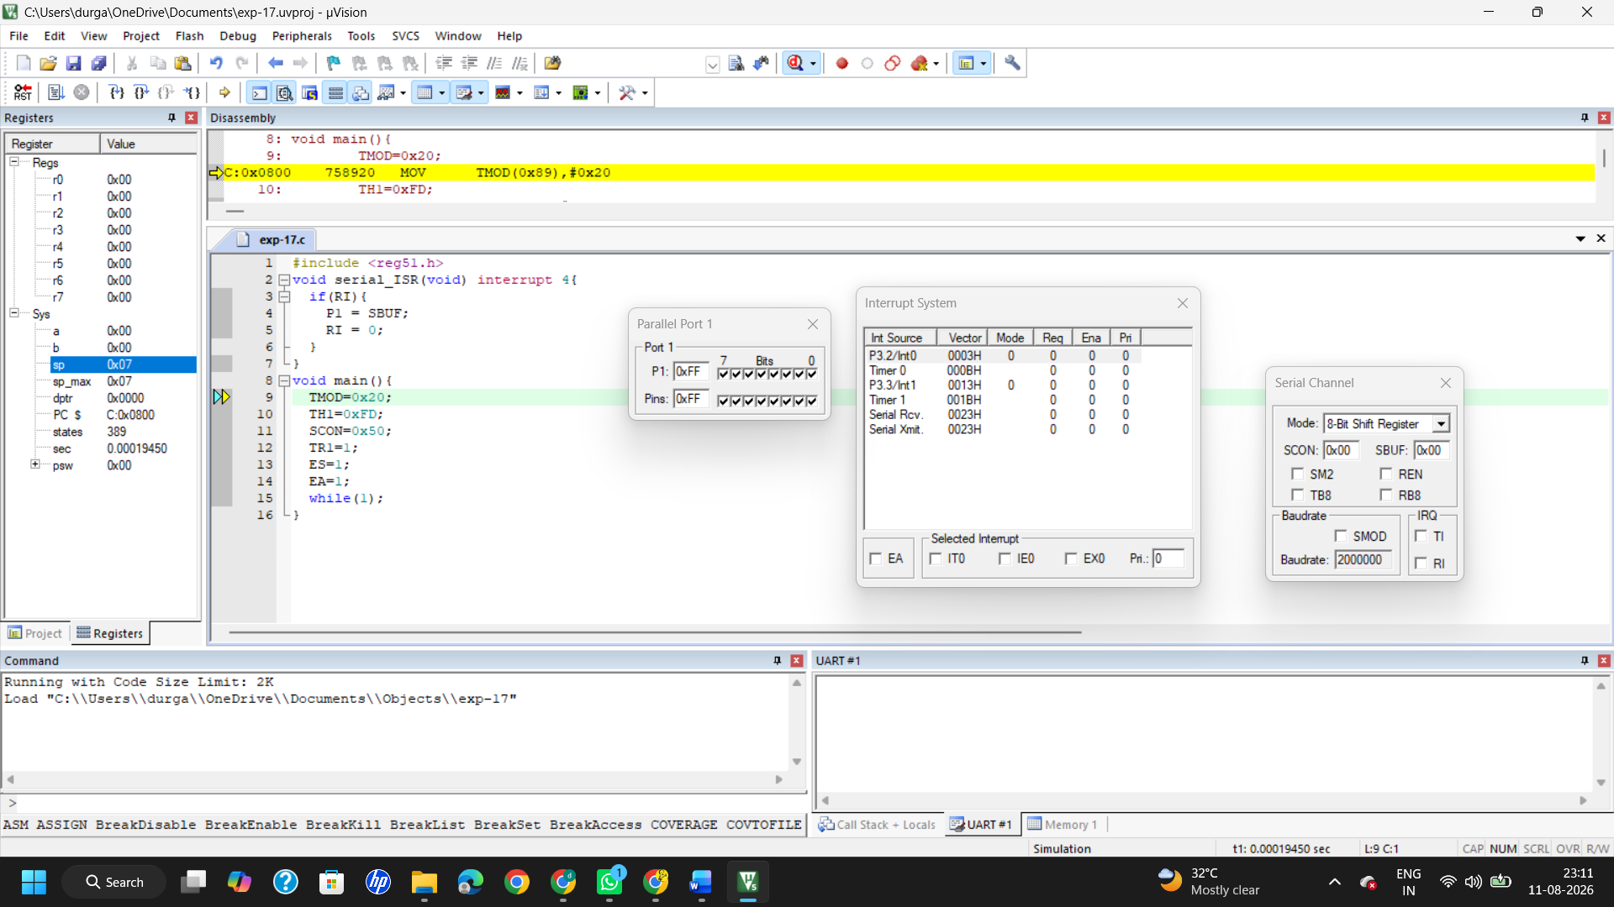
After interrupt:
